**DSS TUTORIAL-1**

**ADDITION / MULTIPLICATION / BAYE’S THEOREM**

Name: Sachita S Limaye

Roll no: 2320030134

Section: S4

1. Addition Theorem of Probability

The Addition Theorem is used to determine the probability that at least one of two events will occur. It ensures that we do not double-count the overlapping outcomes when events are not mutually exclusive.

Mathematical Formula

P(A ∪ B) = P(A) + P(B) - P(A ∩ B)

Mathematical Example

Problem: In a class, the probability that a student likes Mathematics is 0.6, and the probability that a student likes Science is 0.5. The probability that the student likes both subjects is 0.3. What is the probability that a student likes either Mathematics or Science?

Solution: Using the formula: P(A ∪ B) = P(A) + P(B) - P(A ∩ B)  
= 0.6 + 0.5 - 0.3 = 0.8  
Therefore, the probability is 0.8.

Programming Example

Java Code:

import java.util.Scanner;

public class AdditionTheorem {

public static void main(String[] args) {

Scanner sc = new Scanner(System.in);

System.out.print("Enter P(A): ");

double pA = sc.nextDouble();

System.out.print("Enter P(B): ");

double pB = sc.nextDouble();

System.out.print("Enter P(A and B): ");

double pAandB = sc.nextDouble();

double result = pA + pB - pAandB;

System.out.println("P(A or B) = " + result);

sc.close();

}

}

Output:

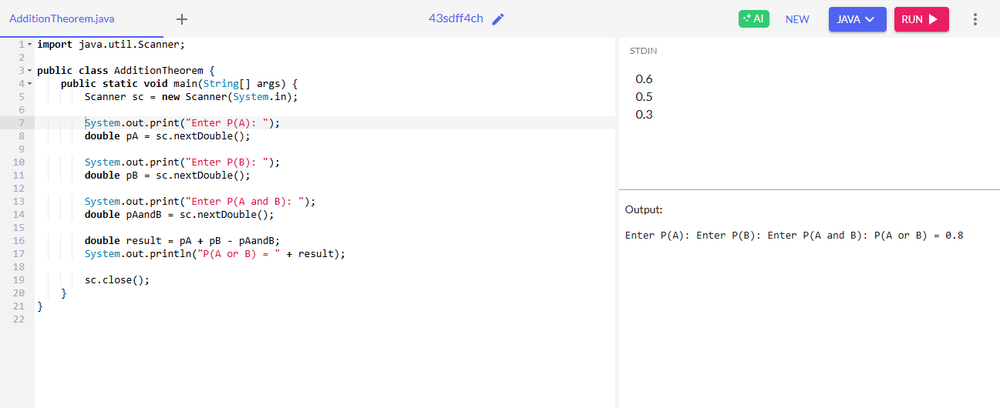

2. Multiplication Theorem of Probability

This theorem is used to find the probability that two events happen together. If the events are independent, it is the product of their probabilities. For dependent events, the second event's probability is conditional on the first.

Mathematical Formula

P(A ∩ B) = P(A) × P(B | A)

Mathematical Example

Problem: A candidate has a 70% chance of passing the written test. If they pass the written test, there's an 80% chance of passing the interview. What is the probability that the candidate passes both rounds?

Solution: P(A ∩ B) = P(A) × P(B|A) = 0.7 × 0.8 = 0.56  
So, the probability of passing both is 0.56.

Programming Example

Java Code:

import java.util.Scanner;

public class MultiplicationTheorem {

public static void main(String[] args) {

Scanner sc = new Scanner(System.in);

System.out.print("Enter P(A): ");

double pA = sc.nextDouble();

System.out.print("Enter P(B | A): ");

double pBGivenA = sc.nextDouble();

double result = pA * pBGivenA;

System.out.println("P(A and B) = " + result);

sc.close();

}

}

Output:

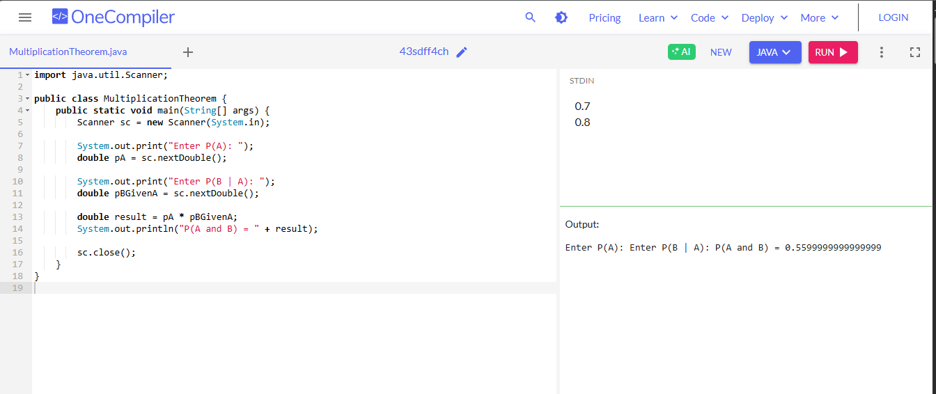

3. Bayes' Theorem

Bayes' Theorem allows updating the probability of a hypothesis based on new evidence. It is widely used in statistics, data science, and machine learning for conditional probability analysis.

Mathematical Formula

P(A|B) = [P(B|A) × P(A)] / P(B)

Mathematical Example

Problem: A disease affects 1% of a population. The test for the disease gives a true positive result 95% of the time and a false positive 10% of the time. If a person tests positive, what is the probability that they actually have the disease?

Solution: Let A = has disease, B = tests positive  
P(A) = 0.01, P(B|A) = 0.95, P(B|¬A) = 0.10, P(¬A) = 0.99  
P(B) = (0.95 × 0.01) + (0.10 × 0.99) = 0.0095 + 0.099 = 0.1085  
P(A|B) = (0.95 × 0.01) / 0.1085 ≈ 0.0876  
So, the probability is approximately 8.76%.

Programming Example

Java Code:

import java.util.Scanner;

public class BayesTheorem {

public static void main(String[] args) {

Scanner sc = new Scanner(System.in);

System.out.print("Enter P(A): ");

double pA = sc.nextDouble();

System.out.print("Enter P(B | A): ");

double pBGivenA = sc.nextDouble();

System.out.print("Enter P(B | not A): ");

double pBGivenNotA = sc.nextDouble();

double pNotA = 1 - pA;

double pB = (pBGivenA * pA) + (pBGivenNotA * pNotA);

double result = (pBGivenA * pA) / pB;

System.out.printf("P(A | B) = %.4f\n", result);

sc.close();

}

}

Output:

